JAVA -310
REPORT
ON
ENCRYPTION AND DECRYPTION OF TEXT OR MESSAGE USING AN UNIQUE KEY
Computer Science and Engineering.
Under The Guidance of
Mrs.Amarinder kaur

Submitted By
Mugle Sruthi - 12109334 – (15).
Manreet - 12109354 – (18).
Surya Mounika -12109394 -(37).
Section - K21KA



In partial fulfilment for the award of the degree of
Department of computer science and engineering
Lovely Professional University, Punjab. (2022-2023)

ACKNOWLEDGEMENT
We express our deep sense of gratitude to our respected and learned guides Mrs.Amarinder kaur their valuable help and guidance, we are thankful to them for the encouragement they have given us in completing the project. we would like to thank
the other faculty members also, at this occasion.
Lastly, we would like to express apperception towards our
group members, our classmates and indebt to our parents for
providing us the moral support and encouragement during our work.

Mugle Sruthi - 12109334 – (15).
Manreet - 12109354 – (18).
Surya Mounika -12109394 -(37).
Github link :https://github.com/Mugle-Sruthi
ROLES:
Mugle Sruthi(15) – Code and Debugging.
Manreet (18) - Code and Debugging.
Mounika (37) - Report.
INTRODUCTION
Encryption and decryption using a unique key is a common technique used to protect sensitive information. Encryption is the process of converting plain text into a cipher text, while decryption is the process of converting cipher text back to plain text. The unique key is used to encrypt and decrypt the data, and it ensures that only authorized users can access the data.

What is encryption?

ENCRYPTION:

Encryption is the process of converting plain text or data into a coded form, called ciphertext, that cannot be read by anyone who doesn't have the key to decipher it

Encryption using an unique key:

Encryption using a unique key involves the following steps:
Step 1: The user selects the data they want to encrypt and generates a unique key.
Step 2: The encryption algorithm uses the unique key to convert the plain text into cipher text.
Step 3: The cipher text is transmitted or stored in a secure location.
What is Decryption?

DECRYPTION:

Decryption is the process of converting ciphertext back into plain text or data so that it can be read and understood.

Decryption using a unique key

Decryption using a unique key involves the following steps:
Step 1: The authorized user retrieves the cipher text.
Step 2: The decryption algorithm uses the unique key to convert the cipher text back to plain text. Step 3: The authorized user can access the plain text.

NEED OF ENCRYPTION AND DECRYPTION:
Encryption and decryption are essential techniques for securing information that needs to be transmitted or stored securely. By encrypting a message or data, it can be protected from unauthorized access or interception by third parties, ensuring the confidentiality and privacy of the information.
Encryption and decryption can be accomplished through various methods, including symmetric-key cryptography, where the same key is used for both encryption and decryption, and public-key cryptography, where a public key is used to encrypt the message, and a private key is used to decrypt it.
Modern encryption algorithms are highly sophisticated and rely on mathematical functions and complex algorithms to generate keys and scramble the data. The strength of an encryption algorithm depends on its key length, and longer keys are generally considered more secure. In summary, encryption and decryption are essential techniques for securing sensitive information, and they are used in various applications, including online transactions, secure messaging, and data storage.

Benefits of encryption and decryption using a unique key:
- Data confidentiality: Encryption and decryption using a unique key ensures that only authorized users can access the data.
- Data integrity: Encryption and decryption using a unique key can be used to detect any unauthorized changes to the data.
- Data security: Encryption and decryption using a unique key ensures that the data is secure, even if it is intercepted by an unauthorized party.

Advantages of encryption and decryption using an unique key.

Confidentiality: Encryption ensures that only authorized parties can read the encrypted message. The encryption process scrambles the original message into an unreadable form that can only be deciphered by the intended recipient with the appropriate decryption key. This provides confidentiality and helps prevent unauthorized access to sensitive information.

Integrity: Encryption can also help ensure the integrity of a message. By encrypting a message, any tampering or modification of the message can be detected by the recipient, since the decryption process will fail if the message has been altered in any way. This helps prevent message tampering or unauthorized changes to the message.

Authentication: Encryption can also be used to authenticate the identity of the sender. Digital signatures can be added to an encrypted message to provide authentication, ensuring that the message originated from a trusted source and has not been modified during transmission.
Compliance: Encryption is often required by regulations and standards such as HIPAA, PCI-DSS, and GDPR. By using encryption, organizations can demonstrate compliance with these standards and avoid potential penalties or legal liabilities.
DESCRIPTION OF PROJECT:

This is a Java program that performs symmetric key cryptography using either the AES or DES algorithms. The program prompts the user to choose between encryption and decryption, and then prompts the user to choose between AES and DES. If AES is chosen, the user is also prompted to choose between 128-bit and 256-bit keys.

After the user has made their selections, the program either generates a new symmetric key for encryption or prompts the user to input a key for decryption. Here is a breakdown of the main parts of the code: generate Syme (String algo, int bits):

This method generates a new symmetric key using the specified algorithm (either AES or DES) and key size (either 128 or 256 bits). The method returns the generated key as a Secret Key object. encrypt (Secret Key key1, String plaintext, String algo):

This method encrypts the given plaintext using the specified symmetric key and algorithm (either AES or DES). The method returns the encrypted text as a Base64-encoded string. decrypt (String hex key, String encrypted text, String algo):
This method decrypts the given encrypted text using the specified symmetric key (provided as a hexadecimal string) and algorithm (either AES or DES). The method prints the decrypted text to the console. main (String[] rags): This is the main method of the program. It prompts the user to choose between encryption and decryption, and then prompts the user to choose between AES and DES. If AES is chosen, the user is also prompted to choose between 128-bit and 256-bit keys. After the user has made their selections, the program either generates a new symmetric key for encryption or prompts the user to input a key for decryption.

WORKING OF CODE:

The code begins with a few import statements that are used to import the required Java packages:

javax.crypto and javax.crypto.spec packages provide classes and interfaces for cryptographic operations, java.security.SecureRandom provides a cryptographically strong random number generator, javax.xml.bind.DatatypeConverter provides methods for converting between String and binary representations of data, and java.util contains various utility classes.

Class Definition:
The code defines a cryptography class and a SymCrypt class. The cryptography class contains methods for generating symmetric keys, encrypting plaintext, and decrypting ciphertext. The SymCrypt class contains the main method that is the entry point for the program.

Symmetric Key Generation: The generateSymKey method in the cryptography class is used to generate a symmetric key based on the specified algorithm and key size:

The method takes two arguments: the name of the algorithm and the key size (in bits). The method returns a SecretKey object that represents the generated symmetric key. The KeyGenerator class is used to generate the key, and the SecureRandom class is used to provide a secure source of randomness for the key.

Encryption:
The encrypt method in the cryptography class is used to encrypt plaintext using the specified symmetric key and algorithm:

The method takes three arguments: the symmetric key, the plaintext to be encrypted, and the name of the algorithm. The method returns the encrypted message in a Base64-encoded string format. The method first creates a Cipher object using the specified algorithm and mode of operation. It then initializes the cipher in encryption mode using the symmetric key. The plaintext is then encrypted using the doFinal method of the Cipher class. The encrypted message is then Base64-encoded and returned.

Decryption:
The decrypt method in the cryptography class is used to decrypt ciphertext using the specified symmetric key and algorithm:

JAVA CONCEPTS:
Inheritance:
Exception handling:
Functional Interface and lambda handling:
Events in Java:
Inheritance: The class cryptography inherits methods from its parent class Object, which is the default superclass of all classes in Java.
- Exception handling: The code uses exception handling to catch and handle exceptions that may occur during runtime. For example, the generateSymKey, encrypt, and decrypt methods throw Exception, which is a generic exception class that represents an exceptional condition that occurred during the execution of the program.
- Functional interface and lambda handling: The code does not use functional interface or lambda handling. These are features introduced in Java 8 that allow for functional programming style in Java.
- Events in Java: The code does not use any event handling mechanism provided by Java, such as the ActionListener interface for handling button clicks in Swing.

METHODS AND TECHNIQUES:

javax.crypto - Java Cryptography API for encryption and decryption
- java.security.SecureRandom - Java SecureRandom class for generating secure random numbers
- javax.crypto.spec.SecretKeySpec - Java SecretKeySpec class for generating secret keys
- javax.xml.bind.DatatypeConverter - Java DatatypeConverter class for converting data to and from different data types
- java.util.Scanner - Java Scanner class for reading user input from the console
- java.util.Base64 - Java Base64 class for encoding and decoding data in Base64 format
The specific methods used in this program are:
- KeyGenerator.getInstance(algo) - Gets an instance of the specified encryption algorithm
- KeyGenerator.init(bitn, ranNum) - Initializes the key generator with the specified bit size and SecureRandom object
- KeyGenerator.generateKey() - Generates a secret key using the initialized key generator
- Cipher.getInstance(algo) - Gets an instance of the specified cipher algorithm
- Cipher.init(Cipher.ENCRYPT_MODE, key1) - Initializes the cipher with the specified mode (encryption) and secret key
- Cipher.doFinal(plaintext.getBytes()) - Encrypts the plaintext using the initialized cipher and returns the encrypted byte array
- Base64.getEncoder().encodeToString(byte_arr) - Encodes the encrypted byte array in Base64 format and returns the encoded string
- DatatypeConverter.parseHexBinary(hex_key) - Parses the hexadecimal string key and returns the corresponding byte array
- new SecretKeySpec(byte_key_array, "AES") - Creates a new SecretKeySpec object with the specified byte array key and algorithm name
- Cipher.init(Cipher.DECRYPT_MODE, key) - Initializes the cipher with the specified mode (decryption) and secret key
- Base64.getDecoder().decode(encrypted_text) - Decodes the encrypted text from Base64 format and returns the corresponding byte array
- Cipher.doFinal(ciphertextBytes) - Decrypts the ciphertext using the initialized cipher and returns the decrypted byte array
- Scanner.nextLine() - Reads the next line of user input from the console
- DatatypeConverter.printHexBinary(SymmetricKey.getEncoded()) - Converts the secret key to a hexadecimal string and returns the string

CONCLUSION:
Encryption and decryption using a unique key is an effective technique for protecting sensitive information. It ensures that only authorized users can access the data and provides data confidentiality, integrity, and security. Organizations should consider using encryption and decryption using a unique key to protect their sensitive information.

SOME SNAPSHOTS OF PROJECT:

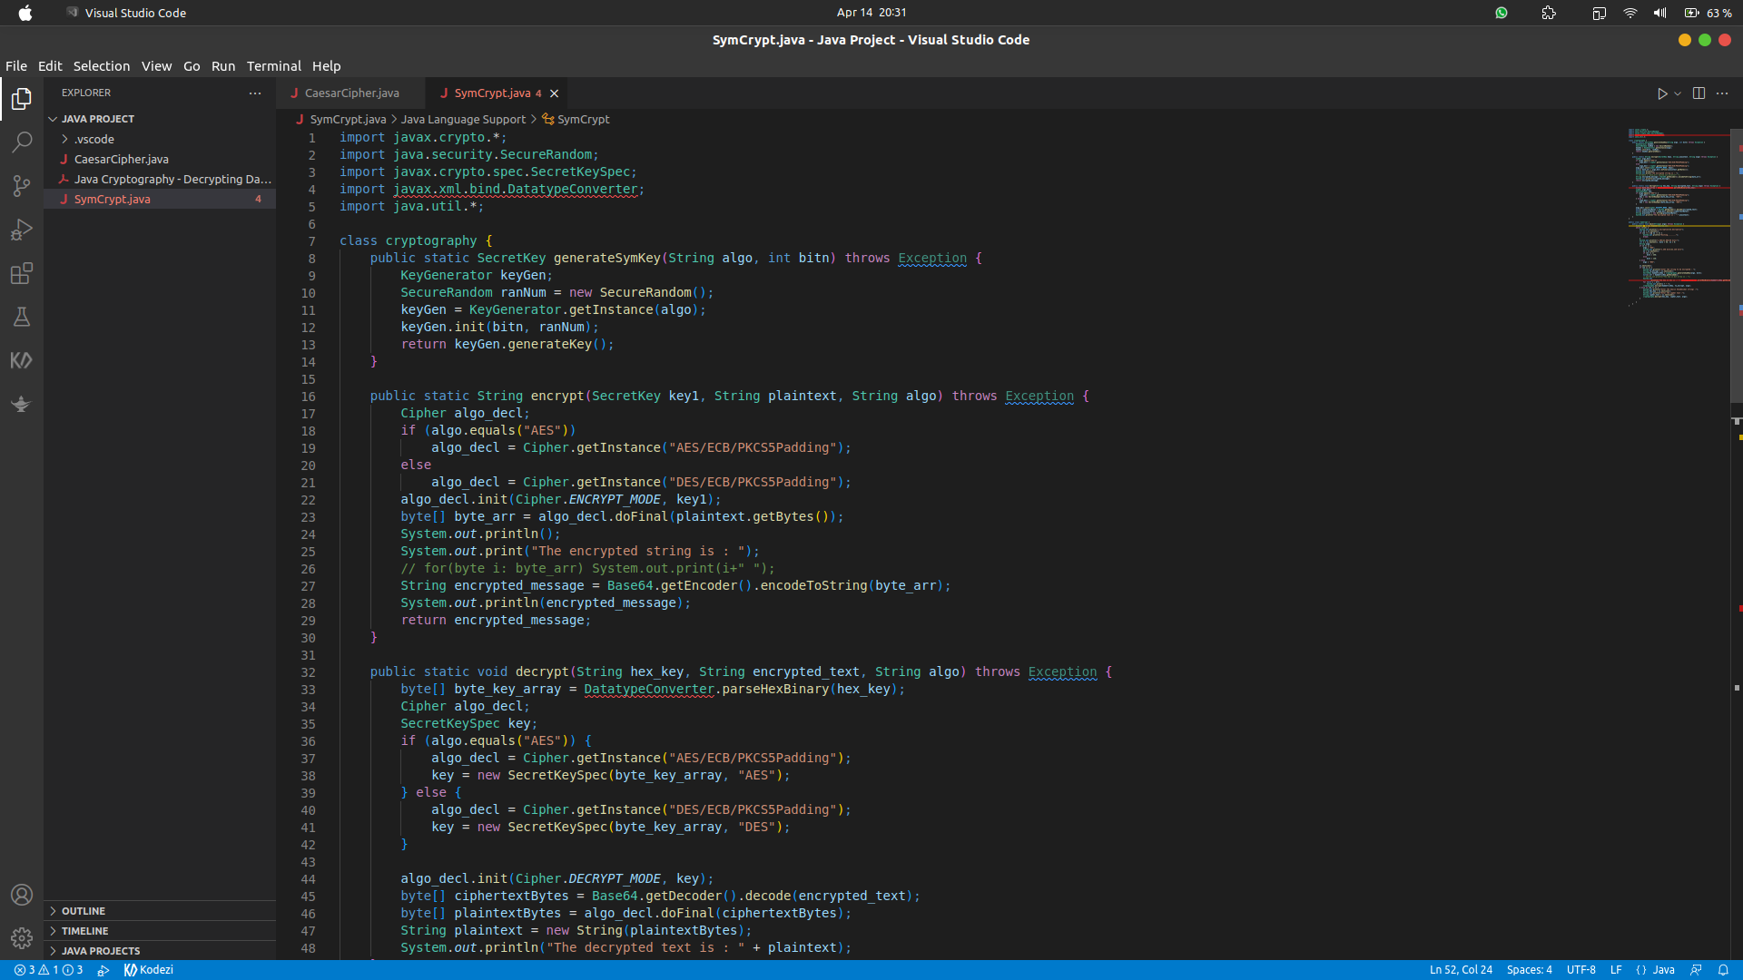

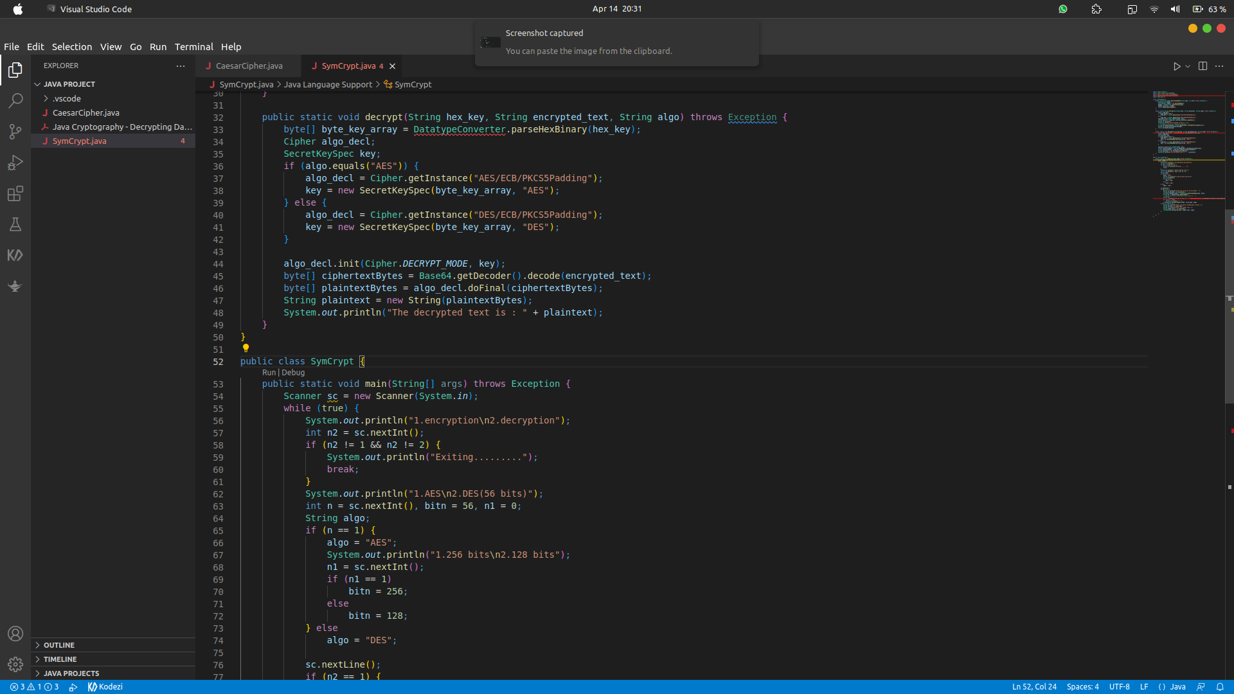

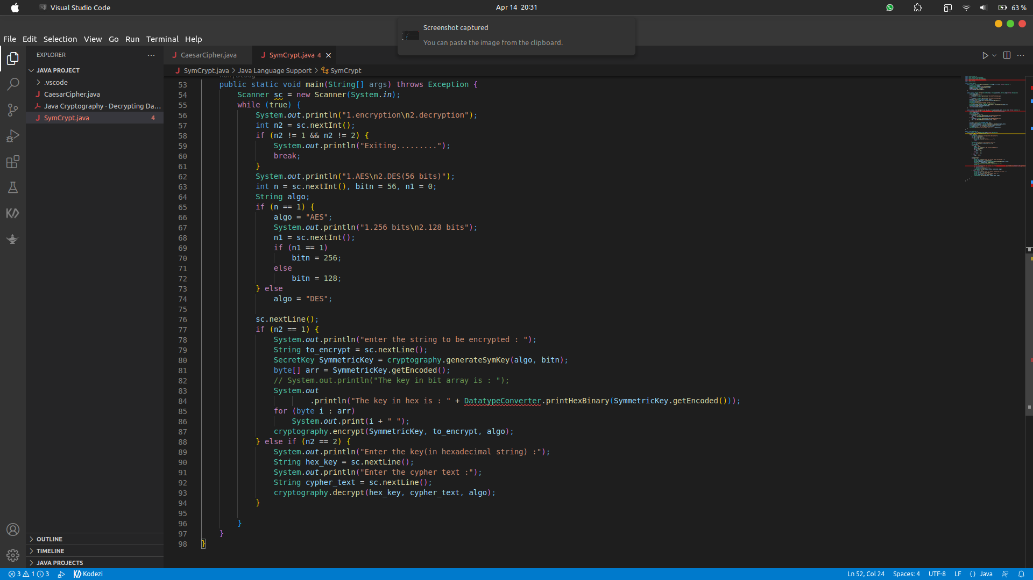
This is the source code of the project :

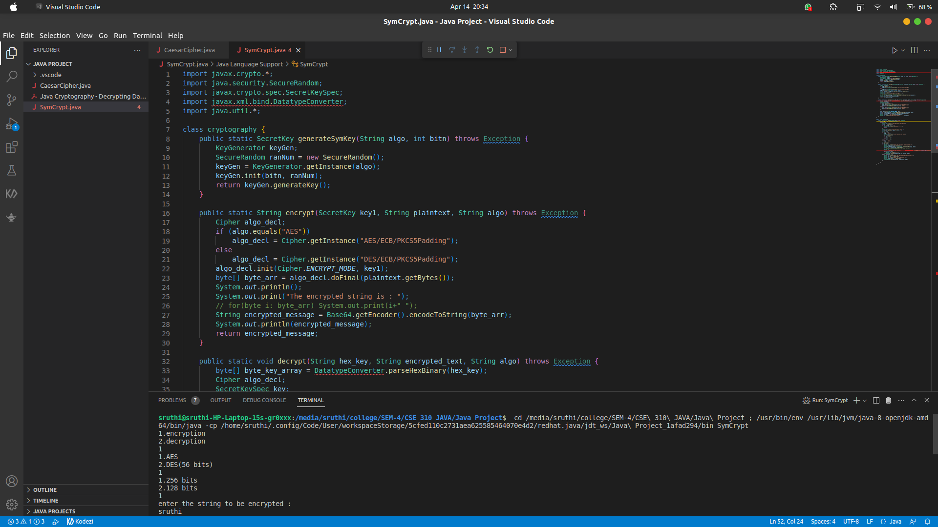
OUTPUT:
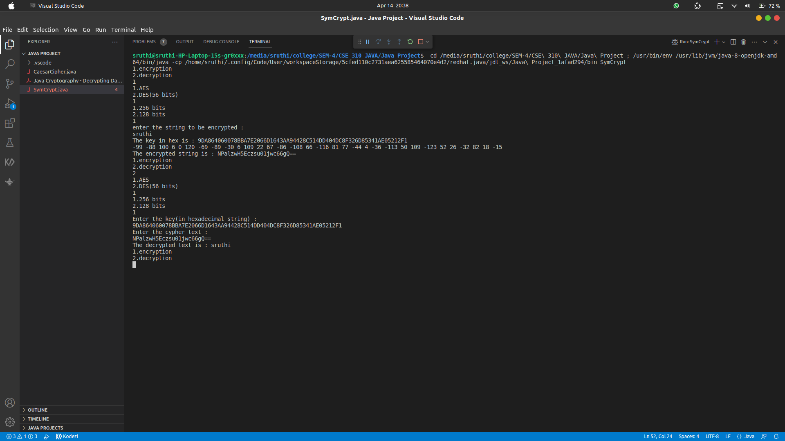
THIS IS THE OUTPUT OF PROJECT:

